Рабочий лист с ответами

Схема движения группы.

Парадное крыльцо (на улице) – зона мастер-классов (2 этаж) – вестибюль (голографическая инсталляция «Современная Россия») – «До 1722» – «1722–1917» – «После 1917» – голографические вентиляторы.

I. Парадное крыльцо (на улице)

№ 1. In the fresco inside the portico, you can see the triumphant people of different jobs and nationalities living in the _________.

- The Union of Soviet Socialist Republics;
- The Russian Federation;
- The Russian Soviet Federative Socialist Republic.

№ 2. You can also see some recognizable buildings in the fresco. Look through the photos and choose the ones in the emblazonment:

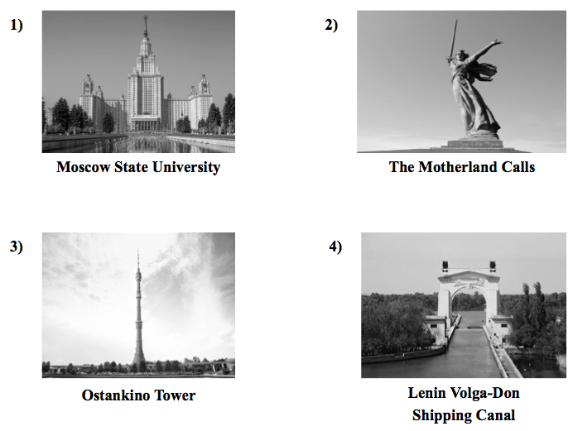

Keys: 1) and 4).

№ 3. Decorations also include some frets reflecting the _________ and _________ revolution in the country. Choose two variants:

- industrial;
- space;
- agricultural.

- Зона мастер-классов (2 этаж)

№ 4. Writing. Fill in the gaps to complete the letter for your English-speaking friend Nick.

Moscow
Russia
01/09/2019

Dear Nick,
Thank you for your letter. It was great to hear from you!
In your letter you asked me about an identity card. Well, here in Russia we don’t have ID cards. We have passports. This is the main document which we use to certify our identity. Each person gets a passport at the age of 14. It’s very easy to do it. You just have to come to a Multifunctional Centre of Public and Municipal Services.
I’m 12 years old now so I’m going to get mine in 2 years. I am looking forward to it!
That’s all for now. My favorite TV programme starts.
Write back soon!
Best wishes,
Name of the student
III. Вестибюль (голографическая инсталляция «Современная Россия»)

№ 5. Watch the virtual installation and choose the correct answer.

1. The Multifunctional Center for Provision of State and Municipal Services has improved the comfort of service / its existence / the minimum terms dramatically.
2. These centres are a modern registration/ benefit / service and a chance to have public services.
3. Such centers are a different level / place / case of providing help.
4. Multifunctional Center is the place where people enjoy their working / free / leisure time.
5. The period of issuing a document takes a lot of / plenty / some days.

IV. Зона артефактов «До 1722», «1722–1917» и «После 1917»

№ 6. Match the objects with their pictures and definitions:

a picture | an object | a defnition
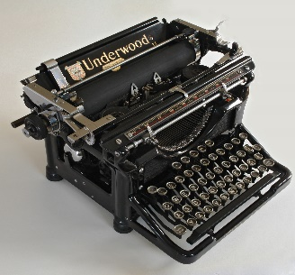 | 5 | a)
 | 3 | b)
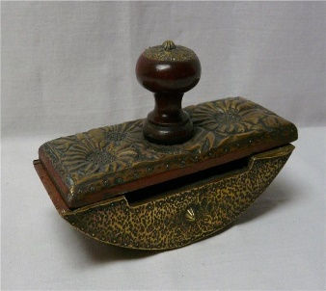 | 6 | f)
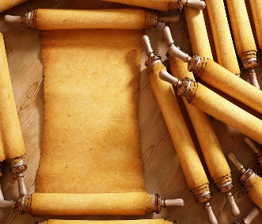 | 1 | d)
 | 2 | c)
 | 4 | e)

- Parchment.
- Ink.
- A passport.
- A paper knife.
- A typewriter.
- A presse papier.

a) A machine with keys for producing letters, numerals, and typographical symbols on paper put round a roller.
- An official document issued by a government to certify identity and citizenship.
- A coloured fluid or paste used for writing, drawing or printing.
- A thin material made from the prepared skin of an animal, usually a sheep or goat, and used instead of paper in ancient and medieval times.
- A tool used for opening envelopes.
- A small, heavy object for keeping papers in place.

Голографические вентиляторы

№ 7. Fill in the gaps with the information you can find on display.

The Uniform of the State Bank Official

This uniform appeared thanks to the establishment of a Loan Bank. In 1804, Emperor Alexander I approved new uniforms for bank clerks. The green color became official for them, and the pale yellow color of the collar, lapels and cuffs (lapels on sleeves) became purple. The senior ranks now had silver embroidering on the collar, cuffs and pockets. And the famous Bank symbol – two horns of plenty with a bee – appeared on the buttons.

The Uniform of a Woman-operator

Women-operators were the first women in the Russian Empire who were allowed to work as telegraph operators. That happened in 1865. A telegraph operator was a person who received and sent telegrams. The main skills for that work were good knowledge of the Russian language, arithmetic and good handwriting. Women-operators wore black coats made of thick fabric, trimmed with yellow welt. It was fastened with two rows of white metal buttons, which were decorated with a special symbol – a telegraph sign, made of two arrows crossing one another. Later crossed post horns were added.

V. Конференц-зал

№ 8. Watch the video and mark the statements as ‘True’ or ‘False’.

You will see the number of the window where the specialist is ________
- in a registration book b) on the screen c) on the invitation card

Until the 17th century the text was written with ________.
- a charcoal b) crayons c) a quill

In the 18th century bondmen without ________ letters were arrested.
- official b) personal c) roadway

In the 19th century _________ was required for leaving abroad from Russia.
a) a passport b) a gramota c) a birth certificate

The exit visa was required for a trip abroad in _________.
- the GDR b) Russia c) the USSR

